Grey’s Anatomy Viewership

*Grey’s Anatomy* is a popular and long-running American medical drama television series. The show was created by *Shonda Rhimes* and premiered on March 27, 2005. Set in the fictional *Grey Sloan Memorial Hospital*, formerly known as *Seattle Grace Hospital*, it revolves around the personal and professional lives of a group of surgical interns, residents, and attending physicians.

The central character of the show is *Dr. Meredith Grey*, played by *Ellen Pompeo*, who serves as the narrator. Throughout the series, viewers follow *Meredith’s* journey as she navigates the challenges of her medical career and the complexities of her personal relationships.

Image(filename='C:\\Users\\lizan\\OneDrive\\Desktop\\grey_s_anatomy_wallpaper_by_cityinmotion_d1es43e-fullview.jpg')



Source: https://www.deviantart.com/cityinmotion/art/Grey-s-Anatomy-Wallpaper-85292474

import os  
import pandas as pd  
import matplotlib.pyplot as plt  
import numpy as np  
from IPython.display import Image  
  
# Set the path  
file_path = "C:\\Users\\lizan\\OneDrive\\Desktop\\RR_quarto_data.xlsx"  
  
# Read data from the source file  
# Source: https://en.wikipedia.org  
df = pd.read_excel(file_path)  
# Preview data  
df.head()

#### Statistics on Viewership:

# Summary of basic statistics on viewership  
viewership_stats = df[['FirstAired_Viewers', 'LastAired_Viewers', 'Avg_viewers', 'Viewership_rank']].describe()  
print("Summary of Basic Statistics on Viewership:")  
print(viewership_stats)

Summary of Basic Statistics on Viewership:  
 FirstAired_Viewers LastAired_Viewers Avg_viewers Viewership_rank  
count 18.000000 18.000000 18.000000 18.000000  
mean 12.377222 11.787778 12.494444 19.833333  
std 5.877135 6.252615 3.688502 8.972179  
min 4.770000 4.190000 6.420000 5.000000  
25% 8.240000 7.680000 10.842500 12.750000  
50% 10.095000 8.955000 11.305000 19.500000  
75% 16.835000 16.872500 14.277500 26.750000  
max 25.410000 22.570000 19.440000 34.000000

* The average viewership of the first episode of each season ranges from approximately 4.77 million to 25.41 million, with a mean of approximately 12.38 million. The standard deviation indicates moderate variability in first-episode viewership across seasons.
* The average viewership of the last episode of each season ranges from approximately 4.19 million to 22.57 million, with a mean of approximately 11.79 million. The standard deviation suggests some variability in last-episode viewership across seasons.
* The average viewership across all episodes within each season ranges from approximately 6.42 million to 19.44 million, with a mean of approximately 12.49 million. The standard deviation indicates moderate variability in average viewership across seasons.
* The viewership ranks of the seasons range from 5 to 34. The mean rank is approximately 19.83, indicating that, on average, the show’s viewership ranks around the middle among all seasons.

# Graph of viewership over time  
plt.figure(figsize=(10, 6))  
plt.plot(df['Season'], df['FirstAired_Viewers'], marker='o', label='First Aired Viewers', color='blue')  
plt.plot(df['Season'], df['Avg_viewers'], marker='o', label='Average Viewers', color='red')  
plt.xlabel('Season')  
plt.ylabel('Viewership (Millions)')  
plt.title('Viewership Over Time')  
plt.legend()  
plt.grid(True)  
plt.xticks(df['Season'])  
plt.tight_layout()  
plt.show()

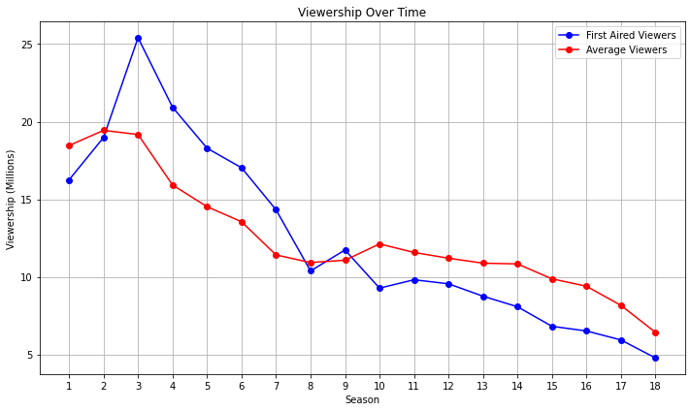

The TV show is experiencing a noticeable decline in audience interest.

# Graph of season-to-season changes in viewership  
episode_changes = np.diff(df['FirstAired_Viewers'])  
seasons = df['Season'][1:] # Exclude the first season as there's no previous season to compare with  
plt.figure(figsize=(10, 6))  
plt.plot(seasons, episode_changes, marker='o', color='purple')  
plt.axhline(0, color='gray', linestyle='dashed', linewidth=1)  
plt.xlabel('Season')  
plt.ylabel('Change in Viewership (Millions)')  
plt.title('Episode-to-Episode Changes in Viewership')  
plt.grid(True)  
plt.xticks(seasons)  
plt.tight_layout()  
plt.show()

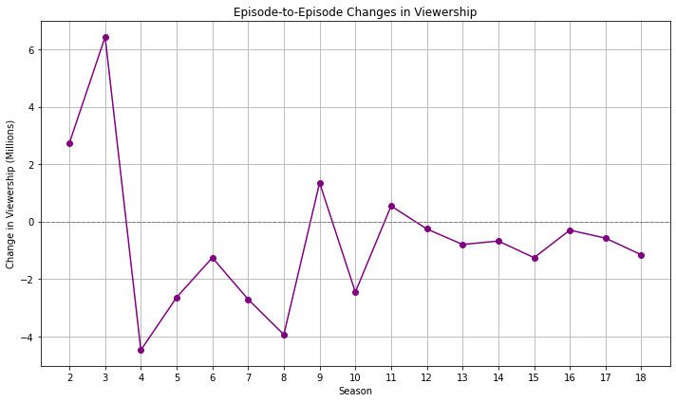

The most significant decline in viewership occurred during the 4th season.

# Changes in viewership  
max_decrease_season1to5 = np.min(episode_changes[:5])  
max_decrease_season3to5 = np.min(episode_changes[2:5])  
max_increase_season16to17 = np.max(episode_changes[15:17])  
  
print(f"The viewership decreased by {max_decrease_season1to5:.2f} million between seasons 1 and 5.")  
print(f"The viewership decreased by {max_decrease_season3to5:.2f} million between seasons 3 and 5.")  
print(f"The viewership increased by {max_increase_season16to17:.2f} million between seasons 16 and 17.")

The viewership decreased by -4.48 million between seasons 1 and 5.  
The viewership decreased by -4.48 million between seasons 3 and 5.  
The viewership increased by -0.58 million between seasons 16 and 17.

Overall, the results indicate that the show experienced a significant viewership decline between the early seasons (1 to 5) and a slight decrease in viewership between seasons 16 and 17. These findings may prompt the show’s creators and producers to analyze the factors that contributed to these declines, such as plot developments, competition from other shows, or changes in marketing strategies. By understanding the reasons behind the viewership changes, they can make informed decisions to address any issues and improve the show’s appeal to the audience.